  MEFCC  MEFCC | Back to Office Report  Evaluate the implementation of the Institutional Strengthening of the Forest Sector Development Program in SNNPR |  | 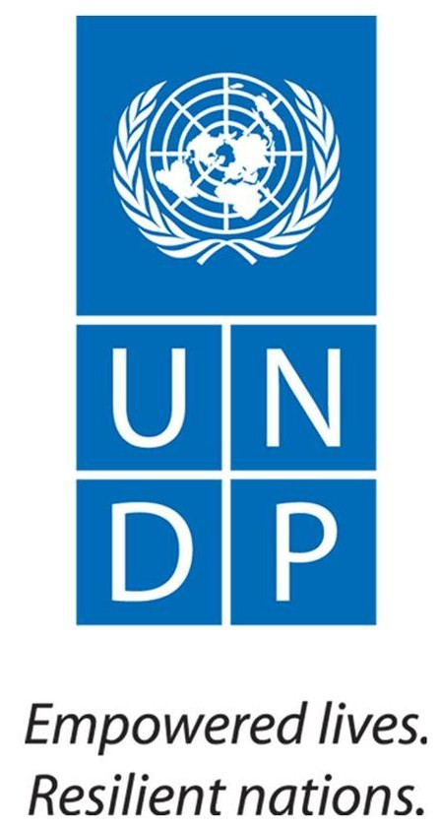
 |  | Mission Date: April 18-27/2016
I. Background :  The five years program on Institutional Strengthening for the Sector Development in Ethiopia has been developed and signed by UNDP and the Ministry of Environment, Forest and Climate Change of the Ethiopian government and its implementation has commenced since July 2015. The overall objective of this program is to strengthen government capacity in the forest sector at all levels and spearhead the implementation of the forestry component contained in the GTP and CRGE Strategy.  The Specific objectives of the program are to:  - Foster institutional strengthening at all levels;  - Enhance and stimulate sustainable forest development in line with GTP and CRGE  - promote popular participation;  - Strengthen Science and Innovation and  - Promote private sector engagement.  The five major pillars of the project are: Institutional development; Forest development; Private sector involvement; Stakeholder engagement and Science and Innovation.  II Mission Objectives  The objectives of the Mission are to:  - Providing technical backstopping for successful implementation of the program activities.  - Assessing implementation status of program activities such as nursery establishment and management, land use and other administrative issues in each woredas and identifying challenging gaps in the implementation of planned activities.  - Gathering feedbacks on the overall progress of the program in general and further resource requirements that are needed all the way to put the program on the ground.  - Introducing newly developed Amharic version of project implementation manual to project woredas and related stakeholders.  III. Participants of the Mission  - Tefera Mengistu (PhD), National Program Coordinator,  - DR. Agena Anjulo; Deputy Director General, Ethiopian Environment and Forest Research Institute  - Professor Fasil Kebede, Advisor; Ethiopian Environment and Forest Research Institute  - Dr Alemu Gezahegn, Director; Ethiopian Environment and Forest Research Institute  - Dr Teshome Tessema, Director; Ethiopian Environment and Forest Research Institute  - Mesfin Tsegaye, Senior Forestry expert, ISFSDP, MEFCC  - Tilahun Tegene, Senior Forestry expert, ISFSDP, MEFCC  - Moges Nigussie, Senior Monitoring and evaluation expert, ISFSDP, MEFCC  IV. Main activities undertaken  Field Evaluation of activities in the three Project Districts  Initial investment activities have been started recently in all the three Project districts of the region and intensive monitoring at field level is required. A technical mission consisting of Federal project staffs and senior researchers visited the project sites to provide technical support and timely assess implementation status of program activities towards achieving expected outcomes. The mission made first visit to West Abaya followed by Lemo and Sodo Districts. Nursery activities, physical structures on plantation and rehabilitation sites were evaluated on site. The status of implementation of the planned activities is generally good but requires serious monitoring and field engagement in the coming two months. The activities started at the nursery sites are fairly good but the mission critically commented to quickly start-up physical activities on plantation and restoration sites.  Discussion with Zonal, District and project staff responsible to support project implementation in the three Districts  The main outcomes of the zonal and district levels discussions in the three districts of the SNNP Regional states are discussed here under;  West Abaya, Lemo and Sodo Gurage  Detail discussion held with decision makers at zonal and district levels including the zonal department head and woreda administration head.  There was good effort made to create awareness of the community and political leaders at various levels through an inception workshop. The woreda level steering committee is functioning well in the district. However, some woreda administration has provided rare support for field activities due to additional commitments related to the current drought (West Abaya, Sodo) while the administration commitment witnessed in Lemo Woreda was extraordinary. Yet, all woredas remain committed to a assign fulltime personnel to support the implementation of the project activities in their respective districts. Accordingly, schedule is agreed to be set soon by the project offices and communicate to the woreda administration for field support to mobilize communities for physical activities on the selected sites.  The mission team commented on the various technical issues observed on the project sites (nursery and plantation) and the visit was taken as vital for all districts.  Regarding the future engagement priorities, the mission provided the serious comments in order to get focused and strengthen preparatory activities for the next planting season.  Training and awareness creation is expected from the Federal project support system on issues of afforestation, climate change and rehabilitation of degraded lands.  There is a need to strengthen the project offices with full staff for effective delivery of outcomes.  Zonal and regional experts as well as site level natural resources extension workers can also be utilized as additional capacities to supplement the project activities.  The zonal structure is found to be stronger and committed in providing proper guidance and support for the implementation of the project activities in most woredas. |  | The major outcomes of the mission are:  - Technical backstopping provided at site and district level to strengthen nursery activities and field level physical interventions  - Implementation status of program activities in each woredas identified.  - Gaps and challenges during implementation of the program activities identified.  - Feedbacks gathered on the overall progress of the program. Besides, the type of resources that are currently needed is known.  - Newly developed Amharic version of project implementation manual introduced to project woredas and related stakeholders.  V. Challenges and Constraints  - The woreda administrative body and experts are tied with other government commitments and project offices get rare support in some woredas;  - The project coordination office is not fully organized in staff and material to fast track field level interventions specially on plantation and rehabilitation sites.  VI. The Way Forward  Through the various discussions (at technical level and administrative level) deliberated in the three districts; the following points were agreed to be priorities in the coming months;  - The experts need to develop base map through simple sketch of present land use categories  - Discussion with local communities to get them committed for physical activities on the ground. This can be strategically supported by organizing community groups/using the existing groups if any  - Strengthening nursery activities to the required standard in the coming months to make seedlings ready for the planting season. Two seasons planting can be considered in the area.  - Organizing the youth group for the various project activities  - Continue working on publicizing the project activity on the ground.
Reported by: Tefera Mengistu (PhD), National Program Coordinator

